A **thread** is a path which is followed during a program’s execution. Majority of programs written now a days run as a single thread. Let’s say, for example a program is not capable of reading keystrokes while making drawings. These tasks cannot be executed by the program at the same time. This problem can be solved through multitasking so that two or more tasks can be executed simultaneously. Multitasking is of two types: Processor based and thread based. Processor based multitasking is totally managed by the OS, however multitasking through multithreading can be controlled by the programmer to some extent. The concept of **multi-threading** needs proper understanding of these two terms – **a process and a thread. A process is a program being executed. A process can be further divided into independent units known as threads. A thread is like a small light-weight process within a process. Or we can say a collection of threads is what is known as a process.**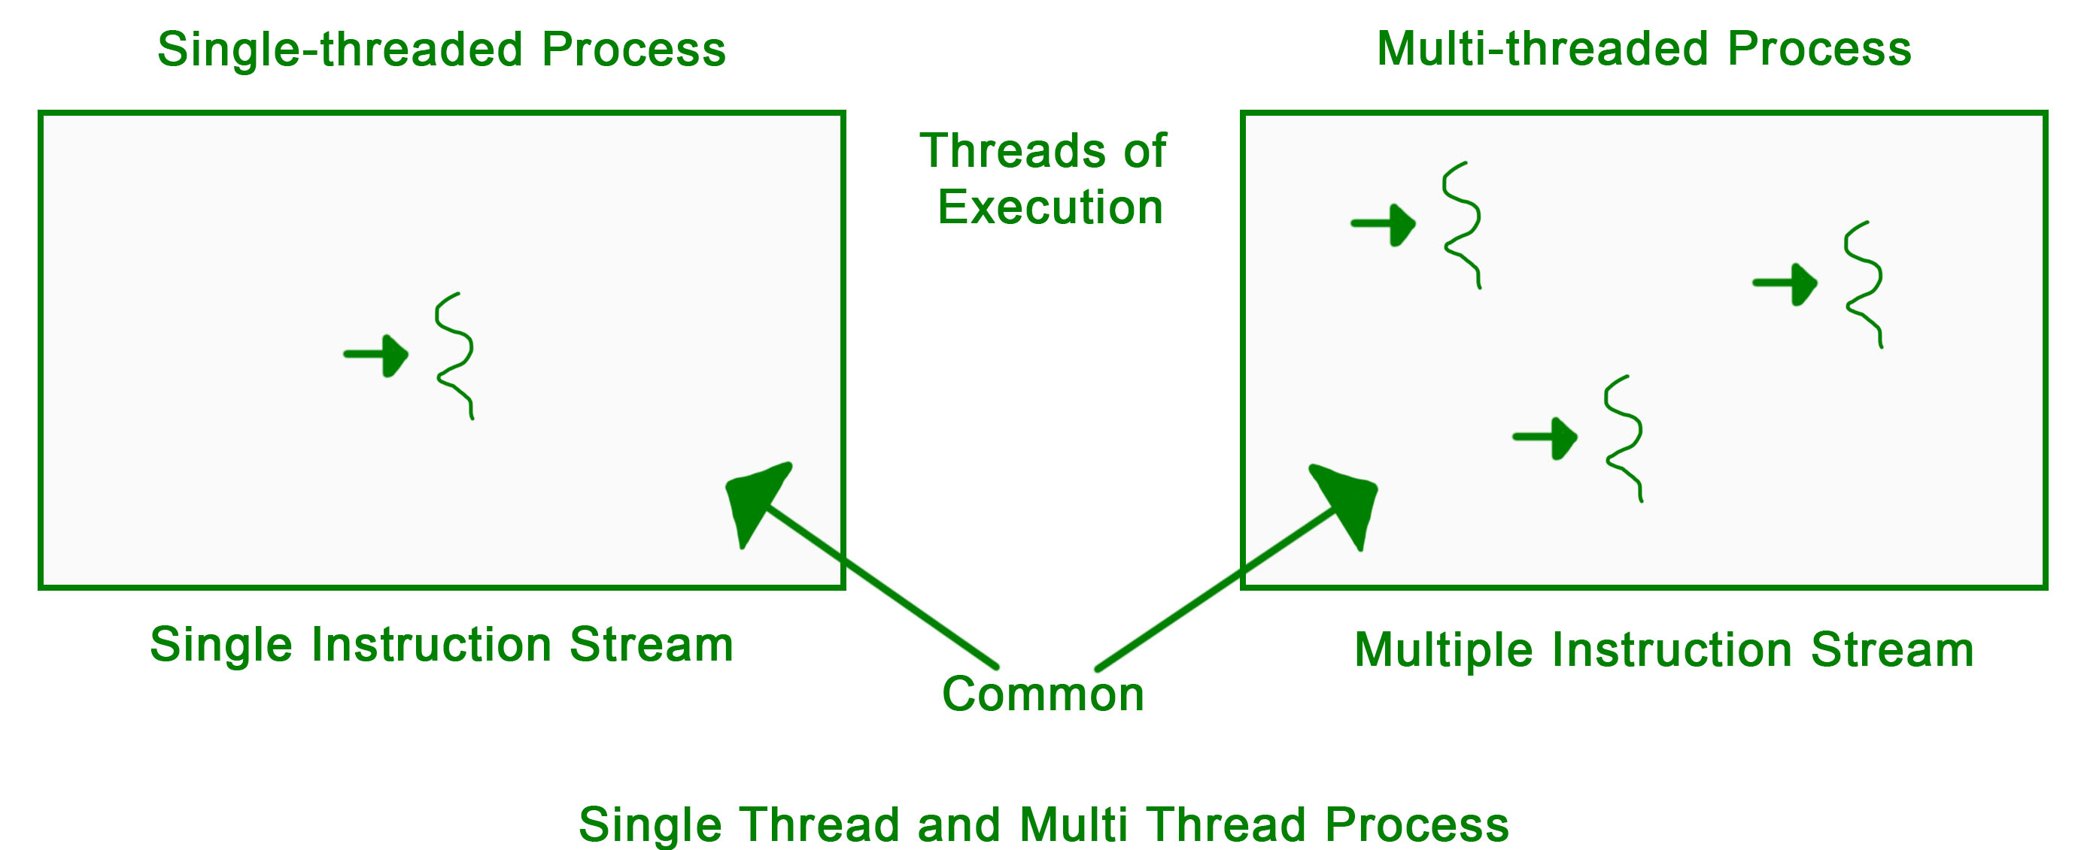

**Applications –** Threading is used widely in almost every field. Most widely it is seen over the internet nowadays where we are using transaction processing of every type like recharges, online transfer, banking etc. Threading is a segment which divide the code into small parts that are of very light weight and has less burden on CPU memory so that it can be easily worked out and can achieve goal in desired field. The concept of threading is designed due to the problem of fast and regular changes in technology and less the work in different areas due to less application. Then as says “need is the generation of creation or innovation” hence by following this approach human mind develop the concept of thread to enhance the capability of programming.

**Lifecycle of a thread**

There are various stages in the lifecycle of a thread. Following are the stages a thread goes through in its whole life.

* **New:**The lifecycle of a born thread (new thread) starts in this state. It remains in this state till a program starts.
* **Runnable**: A thread becomes runnable after it starts. It is considered to be executing the task given to it.
* **Waiting**: While waiting for another thread to perform a task, the currently running thread goes into the waiting state and then transitions back again after receiving a signal from the other thread.
* **Timed Waiting:** A runnable thread enters into this state for a specific time interval and then transitions back when the time interval expires or the event the thread was waiting for occurs.
* **Terminated (Dead)**: A thread enters into this state after completing its task.

**Types of execution in OS**

There are two types of execution:

1. **Concurrent Execution:** This occurs when a processor is successful in switching resources between threads in a multithreaded process on a single processor.
2. **Parallel Execution:**This occurs when every thread in the process runs on a separate processor at the same time and in the same multithreaded process

**Drawbacks of Multithreading**

Multithreading is complex and many times difficult to handle. It has a few drawbacks. These are:

* If you don’t make use of the locking mechanisms properly, while investigating data access issues there is a chance of problems arising like data inconsistency and dead-lock.
* If many threads try to access the same data, then there is a chance that the situation of thread starvation may arise. Resource contention issues are another problem that can trouble the user.
* Display issues may occur if threads lack coordination when displaying data.

**Benefits of Multithreading:**

* Multithreading can improve the performance and efficiency of a program by utilizing the available CPU resources more effectively. Executing multiple threads concurrently, it can take advantage of parallelism and reduce overall execution time.
* Multithreading can enhance responsiveness in applications that involve user interaction. By separating time-consuming tasks from the main thread, the user interface can remain responsive and not freeze or become unresponsive.
* Multithreading can enable better resource utilization. For example, in a server application, multiple threads can handle incoming client requests simultaneously, allowing the server to serve more clients concurrently.
* Multithreading can facilitate better code organization and modularity by dividing complex tasks into smaller, manageable units of execution. Each thread can handle a specific part of the task, making the code easier to understand and maintain.

What is Thread?

A thread is a flow of execution through the process code, with its own program counter that keeps track of which instruction to execute next, system registers which hold its current working variables, and a stack which contains the execution history.

A thread shares with its peer threads few information like code segment, data segment and open files. When one thread alters a code segment memory item, all other threads see that.

A thread is also called a **lightweight process**. Threads provide a way to improve application performance through parallelism. Threads represent a software approach to improving performance of operating system by reducing the overhead thread is equivalent to a classical process.

Each thread belongs to exactly one process and no thread can exist outside a process. Each thread represents a separate flow of control. Threads have been successfully used in implementing network servers and web server. They also provide a suitable foundation for parallel execution of applications on shared memory multiprocessors. The following figure shows the working of a single-threaded and a multithreaded process.

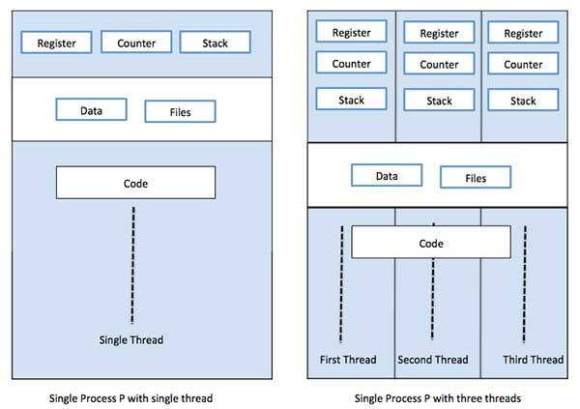

|  |  |  |
| --- | --- | --- |
| **S.N.** | **Process** | **Thread** |
| 1 | Process is heavy weight or resource intensive. | Thread is light weight, taking lesser resources than a process. |
| 2 | Process switching needs interaction with operating system. | Thread switching does not need to interact with operating system. |
| 3 | In multiple processing environments, each process executes the same code but has its own memory and file resources. | All threads can share same set of open files, child processes. |
| 4 | If one process is blocked, then no other process can execute until the first process is unblocked. | While one thread is blocked and waiting, a second thread in the same task can run. |
| 5 | Multiple processes without using threads use more resources. | Multiple threaded processes use fewer resources. |
| 6 | In multiple processes each process operates independently of the others. | One thread can read, write or change another thread's data. |

Difference between Process and Thread

Advantages of Thread

* Threads minimize the context switching time.
* Use of threads provides concurrency within a process.
* Efficient communication.
* It is more economical to create and context switch threads.
* Threads allow utilization of multiprocessor architectures to a greater scale and efficiency.

Types of Thread

Threads are implemented in following two ways −

* **User Level Threads** − User managed threads.
* **Kernel Level Threads** − Operating System managed threads acting on kernel, an operating system core.

User Level Threads

In this case, the thread management kernel is not aware of the existence of threads. The thread library contains code for creating and destroying threads, for passing message and data between threads, for scheduling thread execution and for saving and restoring thread contexts. The application starts with a single thread.

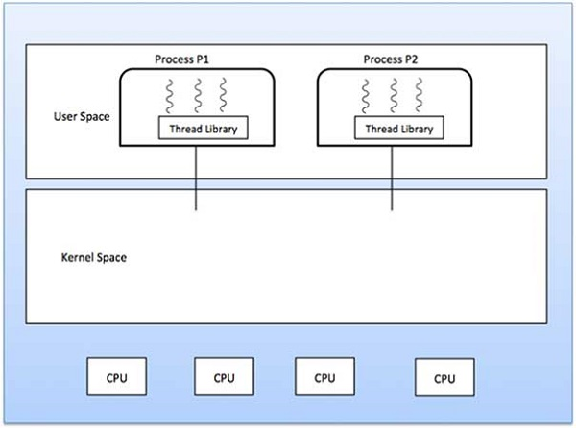

Advantages

* Thread switching does not require Kernel mode privileges.
* User level thread can run on any operating system.
* Scheduling can be application specific in the user level thread.
* User level threads are fast to create and manage.

Disadvantages

* In a typical operating system, most system calls are blocking.
* Multithreaded application cannot take advantage of multiprocessing.

Kernel Level Threads

In this case, thread management is done by the Kernel. There is no thread management code in the application area. Kernel threads are supported directly by the operating system. Any application can be programmed to be multithreaded. All of the threads within an application are supported within a single process.

The Kernel maintains context information for the process as a whole and for individuals’ threads within the process. Scheduling by the Kernel is done on a thread basis. The Kernel performs thread creation, scheduling and management in Kernel space. Kernel threads are generally slower to create and manage than the user threads.

Advantages

* Kernel can simultaneously schedule multiple threads from the same process on multiple processes.
* If one thread in a process is blocked, the Kernel can schedule another thread of the same process.
* Kernel routines themselves can be multithreaded.

Disadvantages

* Kernel threads are generally slower to create and manage than the user threads.
* Transfer of control from one thread to another within the same process requires a mode switch to the Kernel.

Multithreading Models

Some operating system provides a combined user level thread and Kernel level thread facility. Solaris is a good example of this combined approach. In a combined system, multiple threads within the same application can run in parallel on multiple processors and a blocking system call need not block the entire process. Multithreading models are three types

* Many to many relationship.
* Many to one relationship.
* One to one relationship.

Many to Many Model (Two level Model)

The many-to-many model multiplexes any number of user threads onto an equal or smaller number of kernel threads.

The following diagram shows the many-to-many threading model where 6 user level threads are multiplexing with 6 kernel level threads. In this model, developers can create as many user threads as necessary and the corresponding Kernel threads can run in parallel on a multiprocessor machine. This model provides the best accuracy on concurrency and when a thread performs a blocking system call, the kernel can schedule another thread for execution.

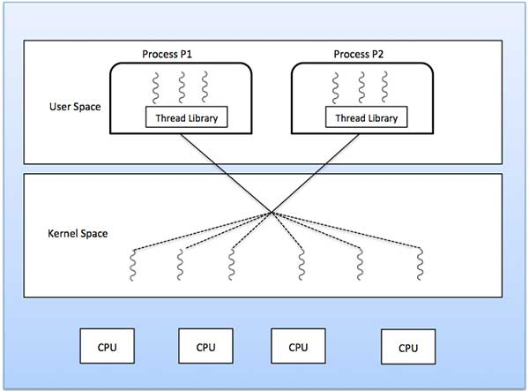

Many to One Model

Many-to-one model maps many user level threads to one Kernel-level thread. Thread management is done in user space by the thread library. When thread makes a blocking system call, the entire process will be blocked. Only one thread can access the Kernel at a time, so multiple threads are unable to run in parallel on multiprocessors.

If the user-level thread libraries are implemented in the operating system in such a way that the system does not support them, then the Kernel threads use the many-to-one relationship modes.

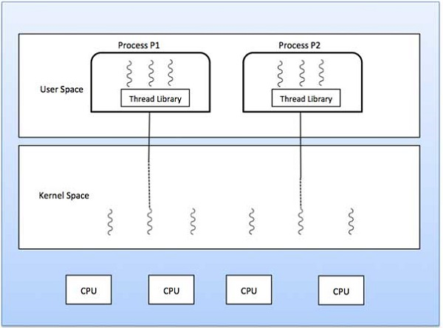

One to One Model

There is one-to-one relationship of user-level thread to the kernel-level thread. This model provides more concurrency than the many-to-one model. It also allows another thread to run when a thread makes a blocking system call. It supports multiple threads to execute in parallel on microprocessors.

Disadvantage of this model is that creating user thread requires the corresponding Kernel thread. OS/2, windows NT and windows 2000 use one to one relationship model.

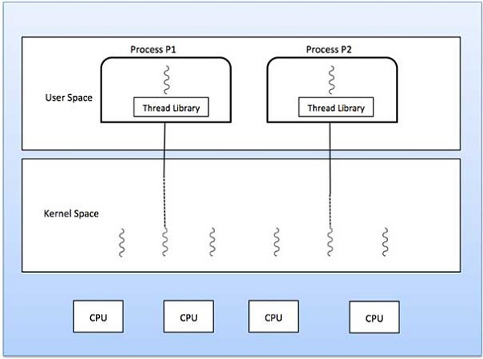

Difference between User-Level & Kernel-Level Thread

|  |  |  |
| --- | --- | --- |
| **S.N.** | **User-Level Threads** | **Kernel-Level Thread** |
| 1 | User-level threads are faster to create and manage. | Kernel-level threads are slower to create and manage. |
| 2 | Implementation is by a thread library at the user level. | Operating system supports creation of Kernel threads. |
| 3 | User-level thread is generic and can run on any operating system. | Kernel-level thread is specific to the operating system. |
| 4 | Multi-threaded applications cannot take advantage of multiprocessing. | Kernel routines themselves can be multithreaded. |